**Types of Machine Learning**

Since we all are aware about machine learning and training and testing data, now let's discuss about the types of machine learning. There are three types of machine learning: **supervised**, **unsupervised** and **reinforcement**. Now let's discuss about each of them.

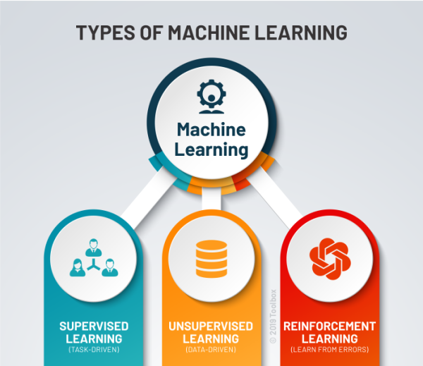

**Supervised learning** or in other words task-driven concentrates on learning patterns through connecting the relationship between variables and known outcomes. It works with labelled data sets.

Now before moving forward let's understand what do we mean by data and what do we mean by label. Data is just information. Whenever we have a table with information such as let's say we have a table which includes test date, all the possible symptoms, age, gender and corona result (whether it's positive or negative) so here we have information that is data. Normally each row is a data point and each column is a feature. In the above example features may be test date, symptoms, gender, age etc. Now then what is label? If we are trying to predict a feature based on the others, then that feature is the label. In the above example we were trying to predict the weather a person is Covid-19 positive or negative based on the symptoms he/she has. Therefore, corona result is a label and this is an example of labelled data set.

Now coming back to supervised machine learning, it works by feeding the machine sample data with various features (usually represented by X) and correct value output of data or label (usually represented by Y). The fact that we already know the output and feature values qualifies the data set as "labelled". Then we use an appropriate algorithm that deciphers the pattern that exist in the data and creates a model that can reproduce the same underlying rules with new data. Supervised learning problems can be for the grouped into regression and classification problems.

Examples of supervised machine learning are regression analysis, decision trees, k nearest neighbors, support vector machine etc.

**Unsupervised learning** or in other words data-driven is where you only have input data (usually represented by X) and no corresponding output variables. These are called unsupervised learning because unlike supervised learning, there is no correct answers and there is no teacher. In the unsupervised machine learning, not all variables and data patterns are classified. Instead, the machine must uncover hidden patterns and create labels through the use of unsupervised learning algorithms.

Examples of unsupervised machine learning are k-means clustering algorithm, Apriori Algorithm etc.

**Reinforcement machine learning** or in other words learn from errors is a machine learning training method which continuously improves its model by feedback from previous iterations. Reinforcement learning is one of the three basic machine learning paradigms, alongside supervised learning and unsupervised learning.

Now let's see how does Reinforcement Learning works?

For example, as cat doesn't understand English or any other human language, we can't tell her directly what to do. Instead, we follow a different strategy. We emulate a situation and cat tries to respond in many different ways. If the cat's response is in the desired way, we will give her treats. Now, whenever the cat is exposed to the same situation, the cat performs a similar action with even more enthusiasm in expectation of getting more reward. In the above example, cat is an agent which is an assumed entity that performs a task. House is the environment which is a scenario that an agent has to face. Treat is the reward which is an immediate return given to an agent when he/she performs specific task. And state is the action or current situation returned by the environment. Therefore, Reinforcement Learning is defined as a machine learning method that is concerned with how agent should take actions in an environment.

This covers the different categories of Machine Learning and how they differ from each other. In the next post, we will be studying about Machine Learning Toolbox.